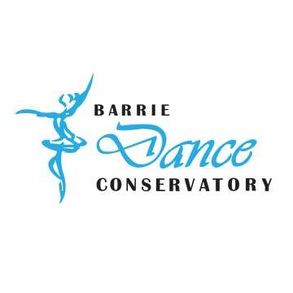

Broadway Bound – The Next Generation
Registration Form 2019

Child’s Information:
Name: ________________________________________ Age: ________ DOB______________________

Parent/Guardian Information:
Name of Registering Parent/Guardian: _____________________________________________________

Address: _____________________________________________________________________________
Street City Postal Code

Email: _______________________________________________________________________________

Home Phone:__________________________________ Cell Phone: _____________________________

Best Number to call during camp times: ____________________________________________________

Official Camp Time 9am-4pm - Please Select The Camp Week
□ July 8 - 12 - GREASE $185.00 plus taxes = $209.05
□ July 15 - 19 - HIGH SCHOOL MUSICAL $185.00 plus taxes = $209.05

Please use a separate registration form if you are registering more than one child.

Please review the BDC Camp Payment information and policies. Sign both the Camp Registration form and The Camp Payment Information and Policies and submit with your deposit or full payment.

___________________________________
Parent/Guardian Signature
Office Use Only

___________________________________
Date:

___________________________________
Staff:

___________________________________
Date:

Barrie Dance Conservatory Inc
Broadway Bound – The Next Generation – Payment & Registration Policies

Please review, sign the bottom and submit with your registration form.
Payment Policies:
- A $50 deposit (non-refundable) is required to secure your registration per week
- The balance is due 2 weeks prior to the camp start date.
- Late payments will be subject to a late fee of 2% per day until the amount is paid in full.
- There is a 30$ fee for chqs that are returned from the bank NSF

Cancellations:
- Cancellations are required two weeks prior to the start date in order to receive a refund. (Not including the non-refundable deposit)
- Cancellations received less than 2 weeks prior to the start date will be subject to a 25$ cancellation fee per week.
- Refunds will not be given once the camp week has begun.

The Barrie Dance Conservatory Inc reserves the right to close facilities, to change instructors, to cancel any activity with insufficient enrollment or to combine programs in which attendance falls below the minimum number required to run a program. We will notify you immediately of any such changes.

Program Removal:
I understand and agree that intentional participant behavior that puts the participant or others at physical or emotional risk may result in immediate dismissal from the program. Any expenses incurred because of program dismissal will be the responsibility of the participant / parent / guardian. Parents/guardians or a suitable designate must be available to pick up participants should the participant be dismissed from his / her program. Refunds will not be issued to students leaving a BDC Inc program prior to the end of the session due to disciplinary action.

Promotional Material Policy:
I understand and agree that BDC Inc and its subsidiaries reserve the right and permission to publish, reproduce, distribute and /or otherwise use any still or moving photograph, for such purposes and with such frequency as it shall determine in its sole discretion without further compensation or consideration to me and without further authorization by me for, as yet, unnamed video or photographic projects (including promotion, marketing and social media) which shall constitute the sole property of BDC Inc. BDC Inc and its subsidiaries shall be released from and against any and all liability resulting from its use of the photos or related to my use of the product.

Release Agreement:
It is understood and agreed that the student(s) and their Parent(s)/Guardian(s) hereby releases the Barrie Dance Conservatory Inc and its staff from any and all damages sustained in consequences of loss, injury or damage to any person or property arising from any cause whatsoever and from any or all actions, claims and demands of any nature.

BDC Inc is not responsible for lost, stolen or damaged personal items. Please label your belongings.

Vandalism will not be tolerated. Parents/Guardians will be responsible for any damages as a result of their child’s behaviour/actions regarding destruction, vandalism and disrespect towards the property of BDC Inc.
I have read the information above and agree with the payment information and registration policies.
Parent Name: _______________________________ Parent Sign: _________________________
Date: _______________________________________ Staff Initial: __________________________

